

**COMPUTER ENGINEERING**

**CG ODD SEM 2021-22/EXPERIMENT 5 NAME:- GAURAV AMARNANI (D7A, 67)**

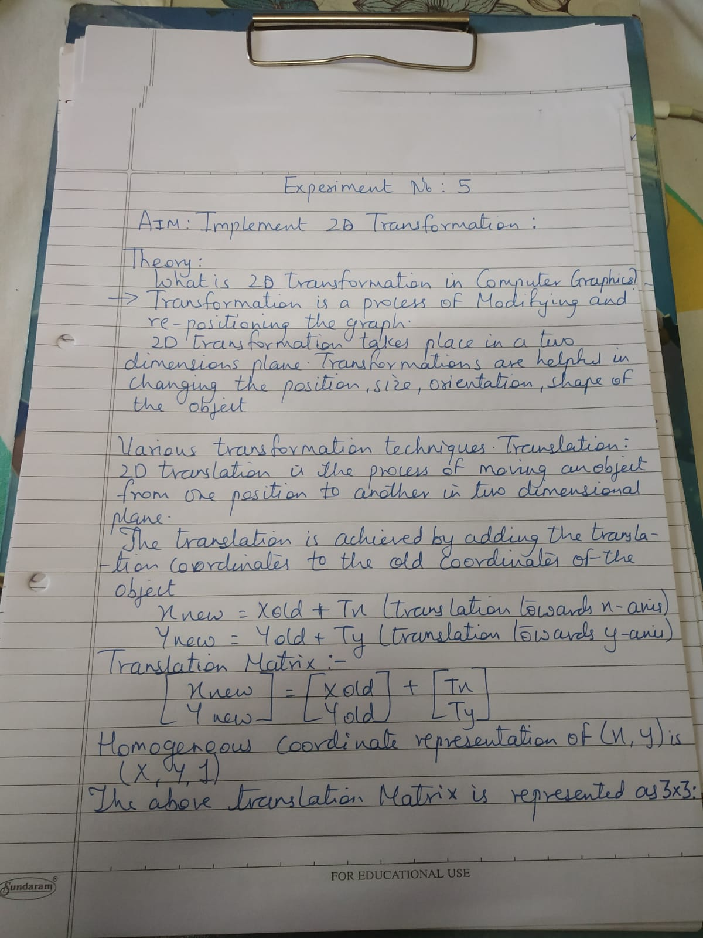

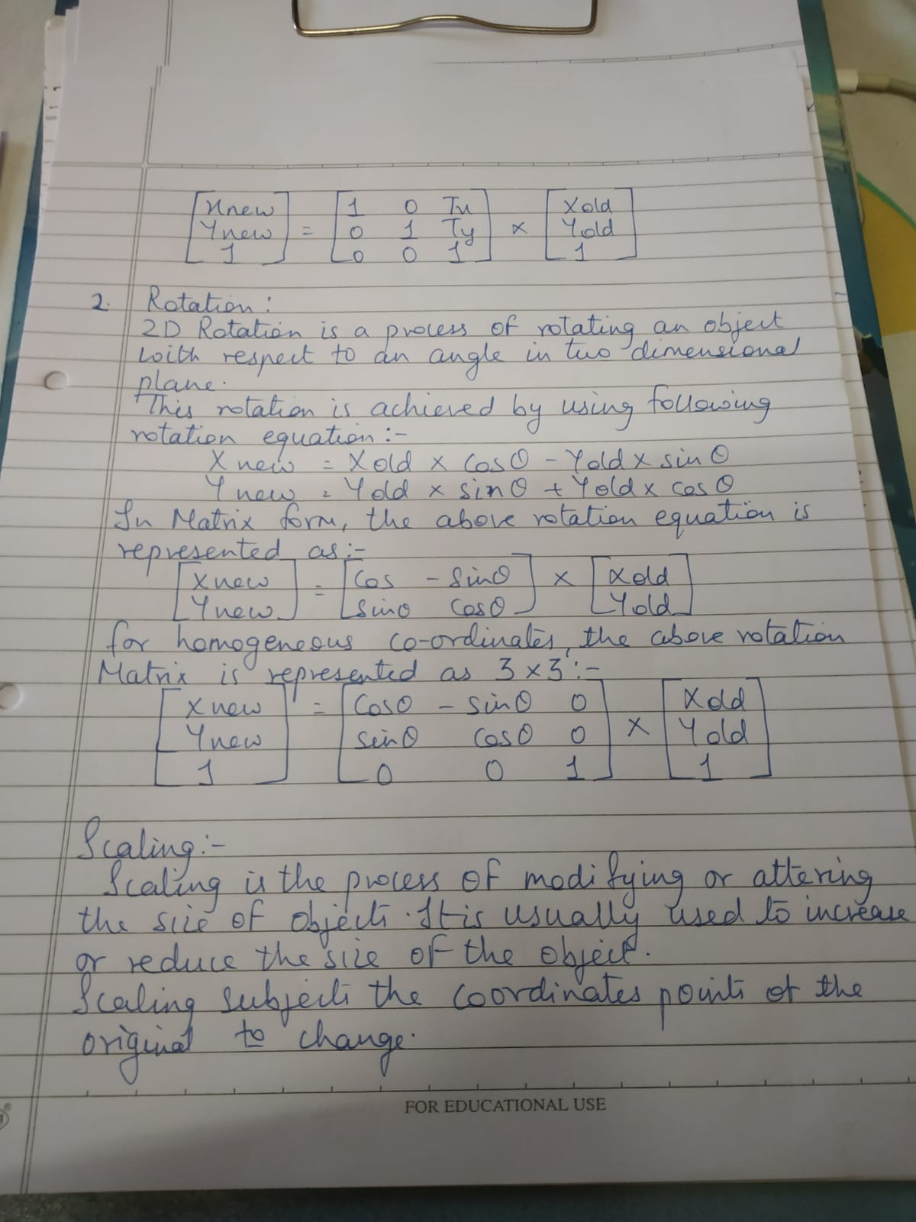

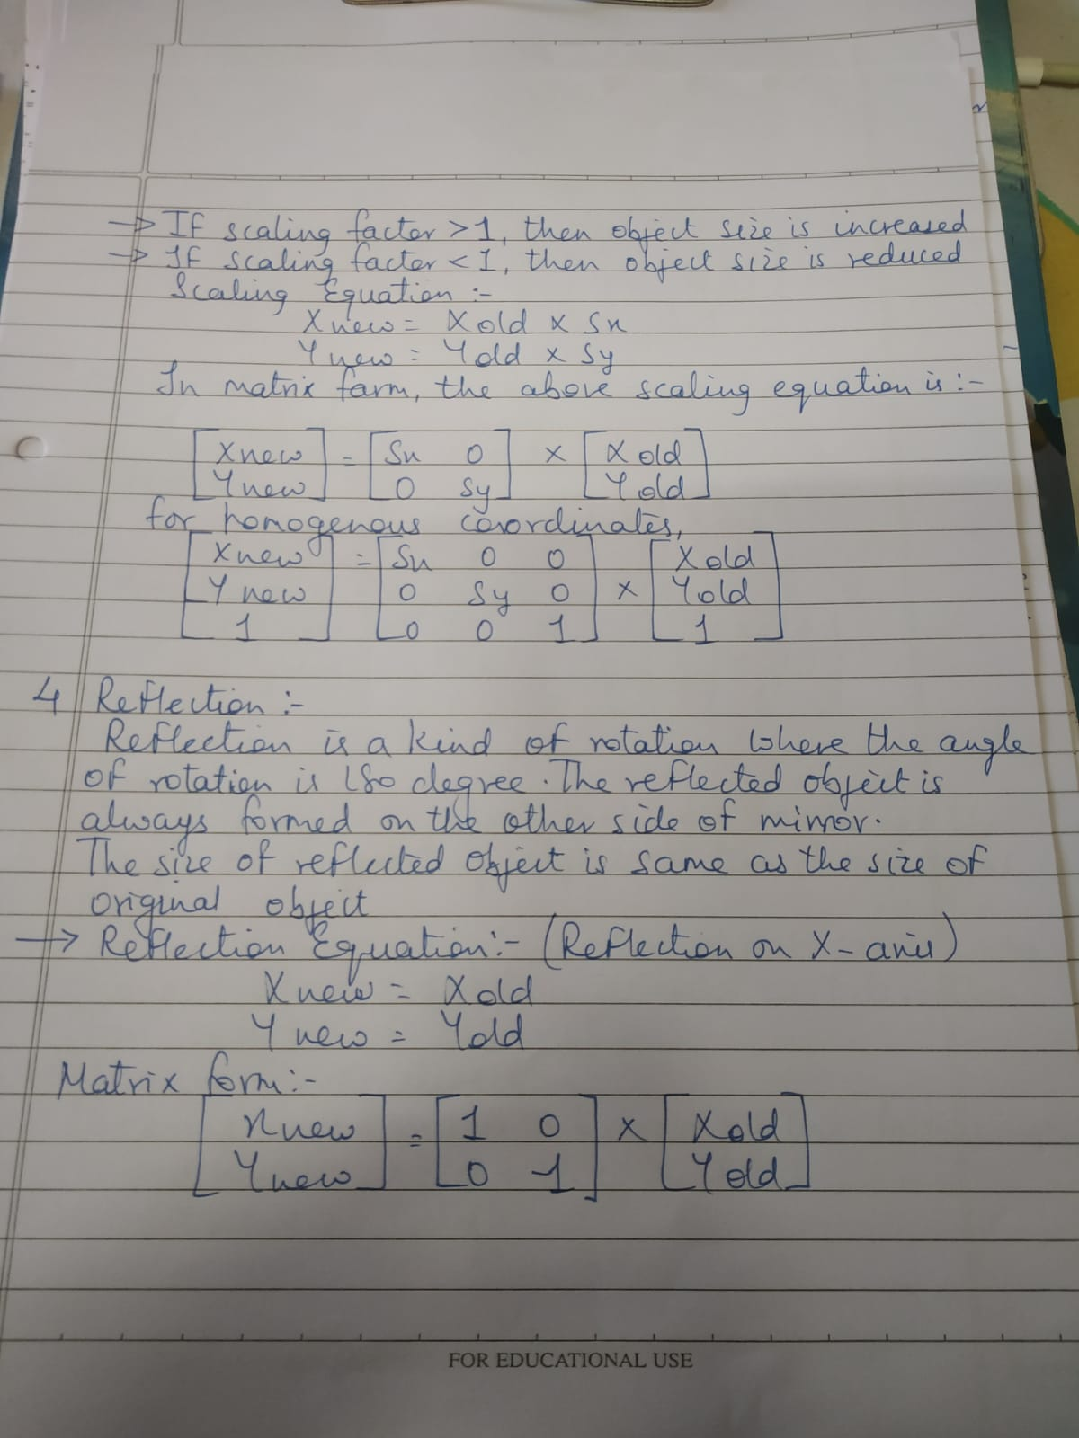

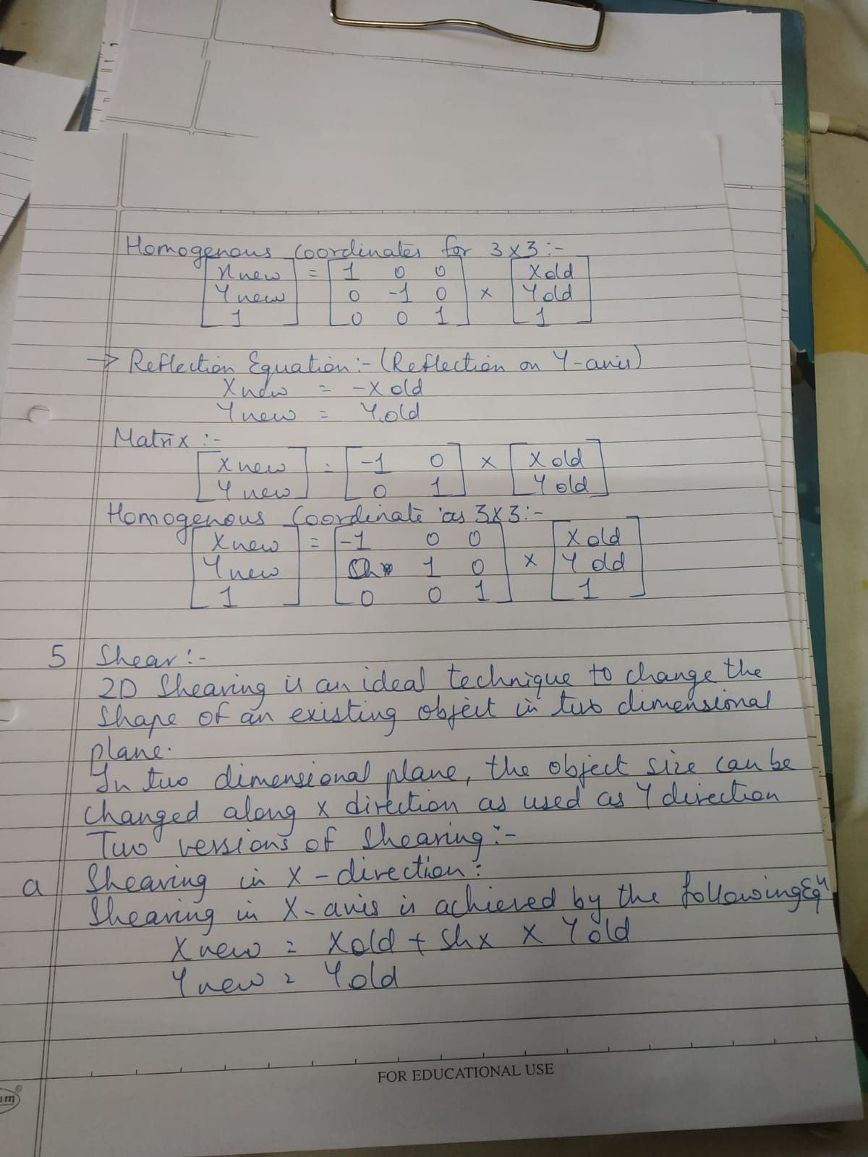

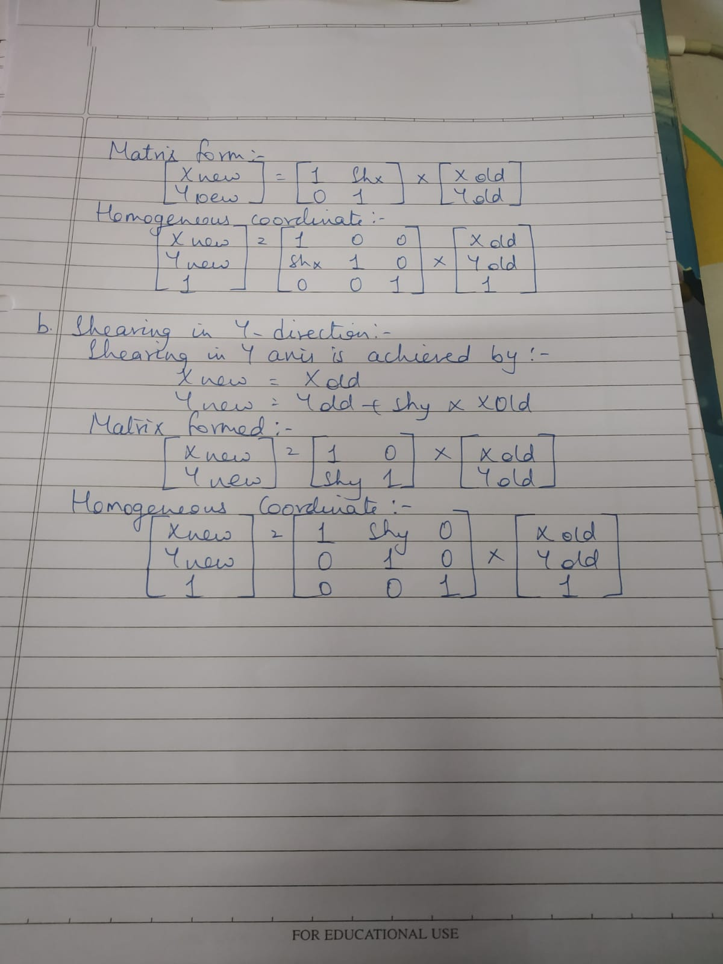

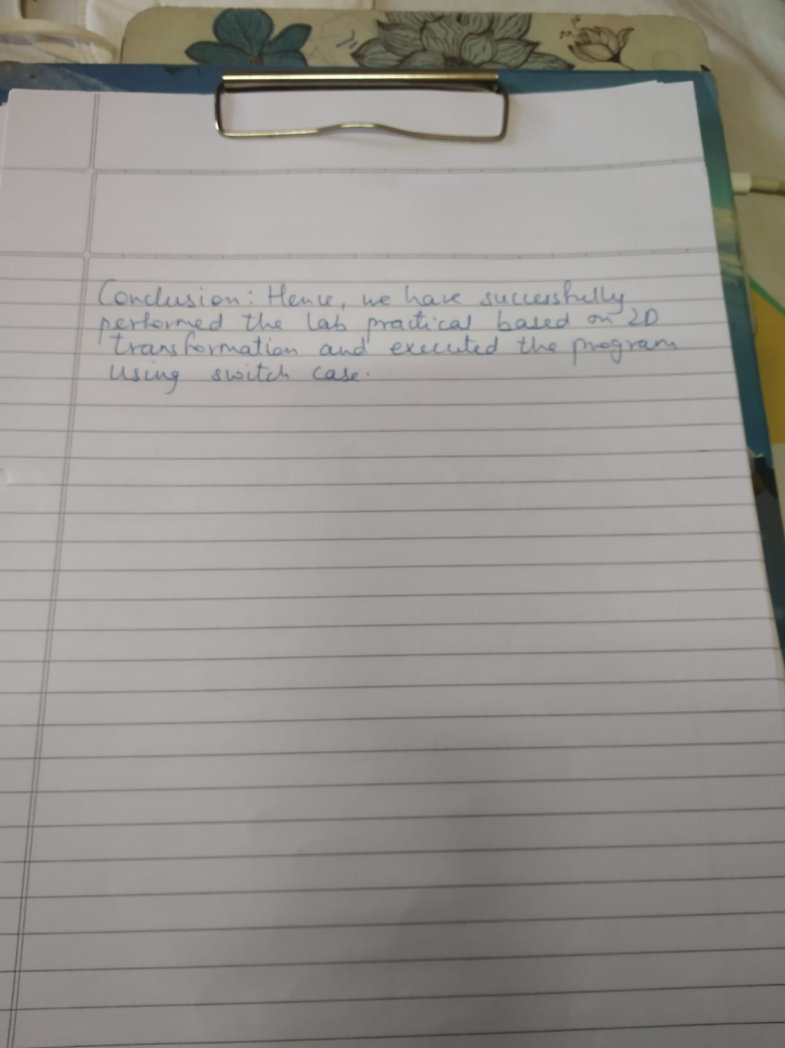

Program:

#include<stdio.h>

#include<graphics.h>

#include<stdlib.h>

#include<math.h>

#include<conio.h>

int x1,y1,x2,y2;

void translation() {

int tx,ty,xn1,xn2,yn1,yn2;

printf("\n Enter the translation\n");

scanf("%d%d",&tx,&ty);

cleardevice();

outtextxy(400,100,"TRANSLATION");

xn1=x1+tx;

yn1=y1+ty;

xn2=x2+tx;

yn2=y2+ty;

line(x1,y1,x2,y2);

line(xn1,yn1,xn2,yn2);

getch();

}

void scaling() {

int xn1,xn2,yn1,yn2;

float sx,sy;

printf("Enter the scaling factor");

scanf("%f%f",&sx,&sy);

cleardevice();

outtextxy(300,200,"SCALING");

xn1=x1*sx;

yn1=y1*sy;

xn2=x2*sx;

yn2=y2*sy;

line(x1,y1,x2,y2);

line(xn1,yn1,xn2,yn2);

getch();

}

void rotation() {

int r;

float rx,xn1,xn2,yn1,yn2;

printf("\n enter the angle for rotation");

scanf("%d",&r); cleardevice();

outtextxy(500,200,"ROTATION");

rx=(r*3.14)/180;

xn1=x1*cos(rx)-y1*sin(rx);

yn1=y1*cos(rx)+x1*sin(rx);

xn2=x2*cos(rx)-y2*sin(rx);

yn2=y2*cos(rx)+x2*sin(rx);

line(x1,y1,x2,y2);

line(xn1,yn1,xn2,yn2);

getch();

}

void shearing() {

float sh;

float xn1,xn2,yn1,yn2;

printf("\n Enter the value for shearing");

scanf("%f",&sh);

cleardevice();

outtextxy(500,100,"SHEARING");

xn1=x1+sh*y1;

yn1=y1;

xn2=x2+sh*y2;

yn2=y2;

line(x1,y1,x2,y2);

line(xn1,yn1,xn2,yn2);

getch();

}

void reflection() {

int xn1,xn2,yn1,yn2;

cleardevice();

outtextxy(300,100,"REFLECTION");

if((x1<y1)^(x2<y2)) {

xn1=x1+50;

xn2=x2+50;

yn1=y1;

yn2=y2;

} else {

xn1=x1;

xn2=x2;

yn1=y1+50;

yn2=y2+50;

}

line(x1,y1,x2,y2);

line(xn1,yn1,xn2,yn2);

getch();

}

void get() {

printf("\n Enter the coordinates x1,y1,x2,y2");

scanf("%d%d%d%d",&x1,&y1,&x2,&y2);

outtextxy(200,100,"ORIGINAL OBJECT");

line(x1,y1,x2,y2); getch();

}

void main() {

int ch,gd=DETECT,gm;

initgraph(&gd,&gm,"c:\\tc\\bgi");

get();

do {

cleardevice();

outtextxy(10,10,"1)TRANSLATION");

outtextxy(10,20,"2)SCALING");

outtextxy(10,30,"3)ROTATION");

outtextxy(10,40,"4)SHEARING");

outtextxy(10,50,"5)REFLECTION");

outtextxy(10,60,"6)EXIT");

outtextxy(10,70,"ENTER UR CHOICE:");

scanf("%d",&ch);

switch(ch) {

case 1: translation(); break;

case 2: scaling(); break;

case 3: rotation(); break;

case 4: shearing(); break;

case 5: reflection(); break;

case 6: exit(0);

}

} while(ch<6);

}

Output:

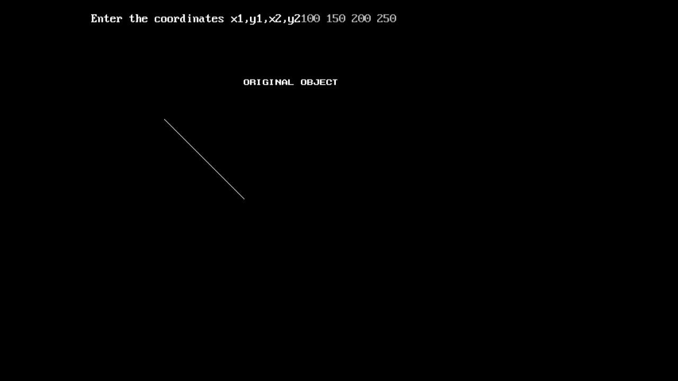

1. **TRANSLATION:-**

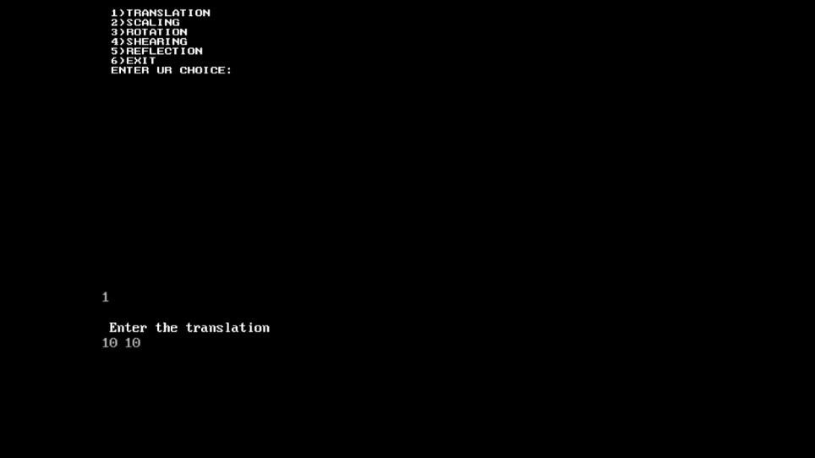

1. **SCALING:-**



1. **ROTATION:-**



1. **SHEARING:-**



1. **REFLECTION:**

